Practicum Statements Regarding Integers., Simple Induction Principle., Extended Induction Principle, Strong Induction Principle., General Form of Induction, Algorithms., Notation for Algorithms., Some Examples of Algorithms., Integers.
WEEK 15

Subject:
Computational Mathematics
Prepared by:
Aisyah Currents
25091397108
Class International/Number 2


INFORMATICS MANAGEMENT STUDY PROGRAM
FACULTY OF VOCATION
UNIVERSITAS NEGERI SURABAYA
YEAR 2025
Table of Contents
PRACTICUM Part 1: Applications of Matrices., Relations., Representation of Relations with Tables., Matrices., and with Directed Graphs. 3
PRACTICUM Part 2: Case studies of Matrices., Relations., Representation of Relations with Tables., Matrices., and with Directed Graphs. 8
PRACTICUM Part 3: Practice Exercises of Matrices., Relations., Representation of Relations with Tables., Matrices., and with Directed Graphs. 14
PRACTICUM Part 4: Applications of Inverse Relations., Combining Relations., Composition of Relations., Properties of Relations., Equivalence Relations. 23
PRACTICUM Part 5: Practice Exercises of Inverse Relations., Combining Relations., Composition of Relations., Properties of Relations., Equivalence Relations. 29
PRACTICUM Part 6: Applications of Partial Order Relations., Closure of Relations., N-ary Relations., Functions. 35
PRACTICUM Part 7: Practice Exercises of Partial Order Relations., Closure of Relations., N-ary Relations., Functions. 40
PRACTICUM Part 8: Applications of Inverse Functions., Composition of Functions., Some Special Functions., Recursive Functions. 48
PRACTICUM Part 9: Practice Exercises of Inverse Functions., Composition of Functions., Some Special Functions., Recursive Functions. 54

PRACTICUM Part 1: Applications of Statements Regarding Integers., Simple Induction Principle., Extended Induction Principle.
- Statements Regarding Integers
Mathematical induction is a proof method that is often used to show that a statement holds for all integers. This practicum aims to understand the concept of mathematical induction and apply it with Python through simple simulations and implementations.
Statements about whole numbers are often expressed in formula form.
• The sum of the first n whole numbers
Sn​=1+2+3+⋯+n = (n(n+1)​ )/2
• The sum of the squares of the first n whole numbers
Qn​=12+22+32+⋯+n2 = (n(n+1)(2n+1))/6​
Prove that the sum of the first n whole numbers is Sn​=(n(n+1))/2​
The Source Code with output
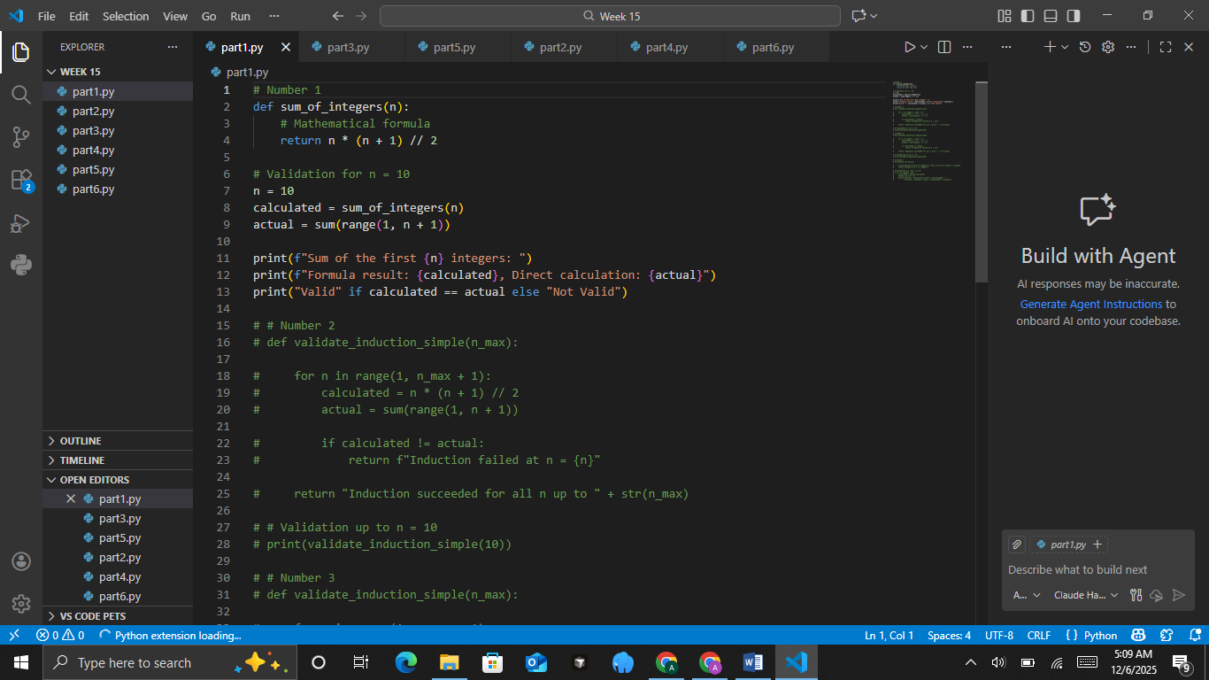
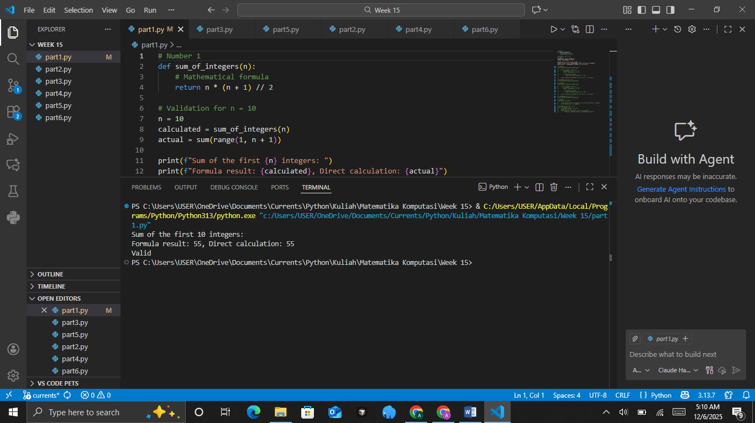

The Analysis

- Simple Induction Principle
This principle involves three steps:
- Base Case
Show that the statement is true for n=1.
- Inductive Hypothesis
Assume the statement is true for n=k.
- Inductive Step
Prove the statement for n=k+1 using the inductive hypothesis.
Prove the following formula:
Sn​=n(n+1)/2
​The Source Code with output
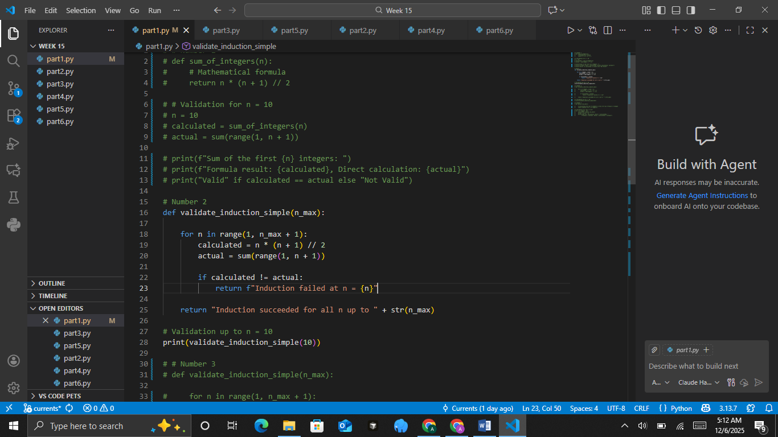
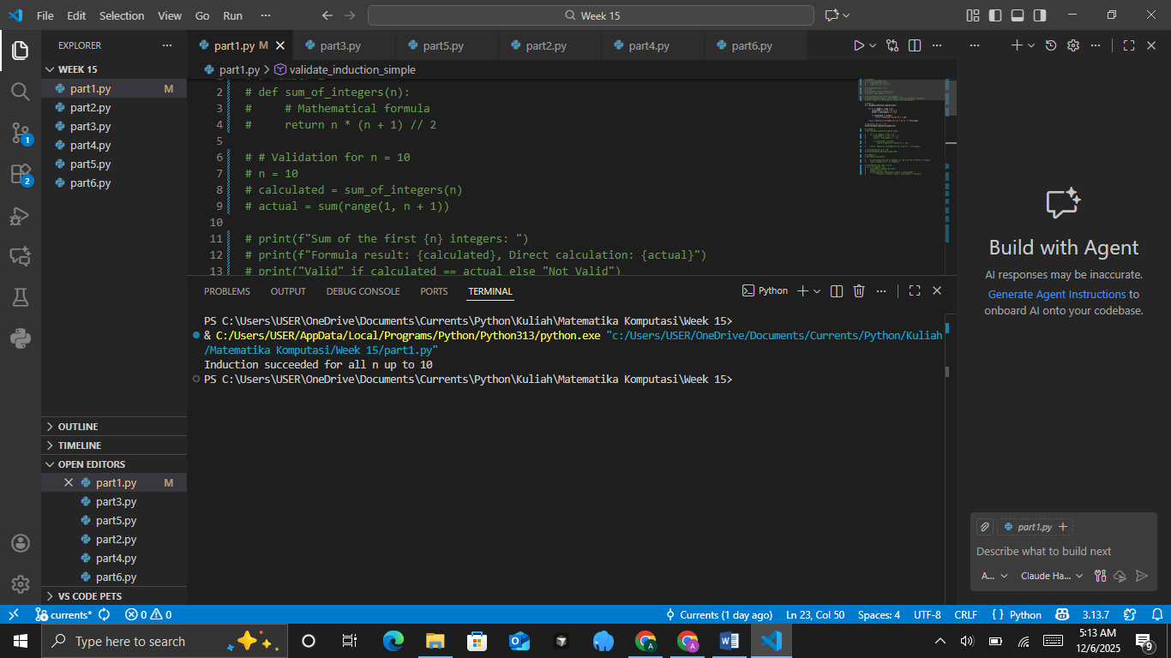
​The Source Code with output
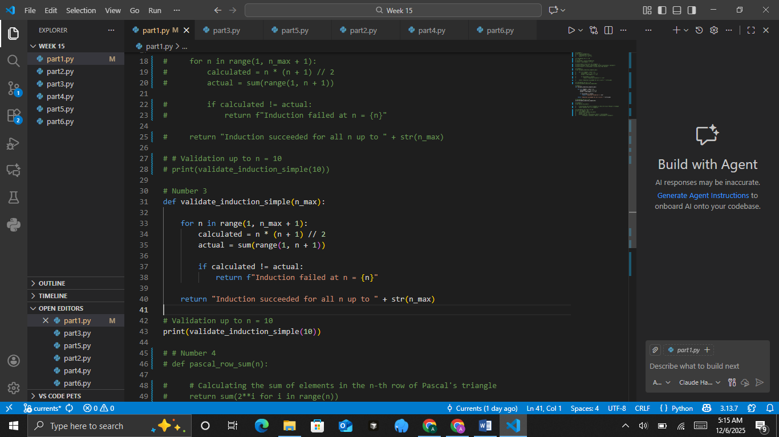
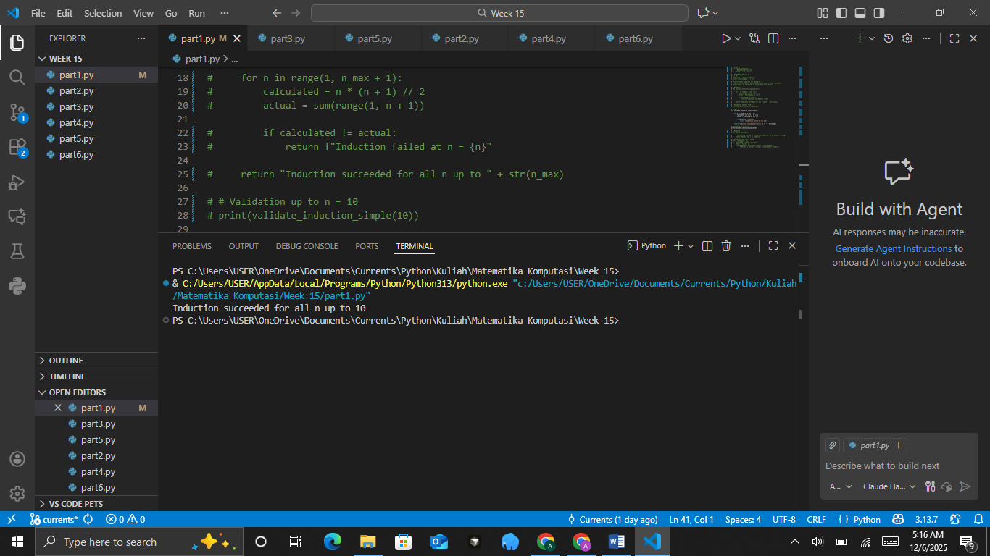
The Analysis
- Extended Induction Principle
This principle is a more general form of simple induction, which states that if the statement is true for all values n ≤ k, then the statement is also true for n = k+1.
Prove that the number of elements in the n-th row of Pascal's triangle is 2^n−1.
The Source Code with output
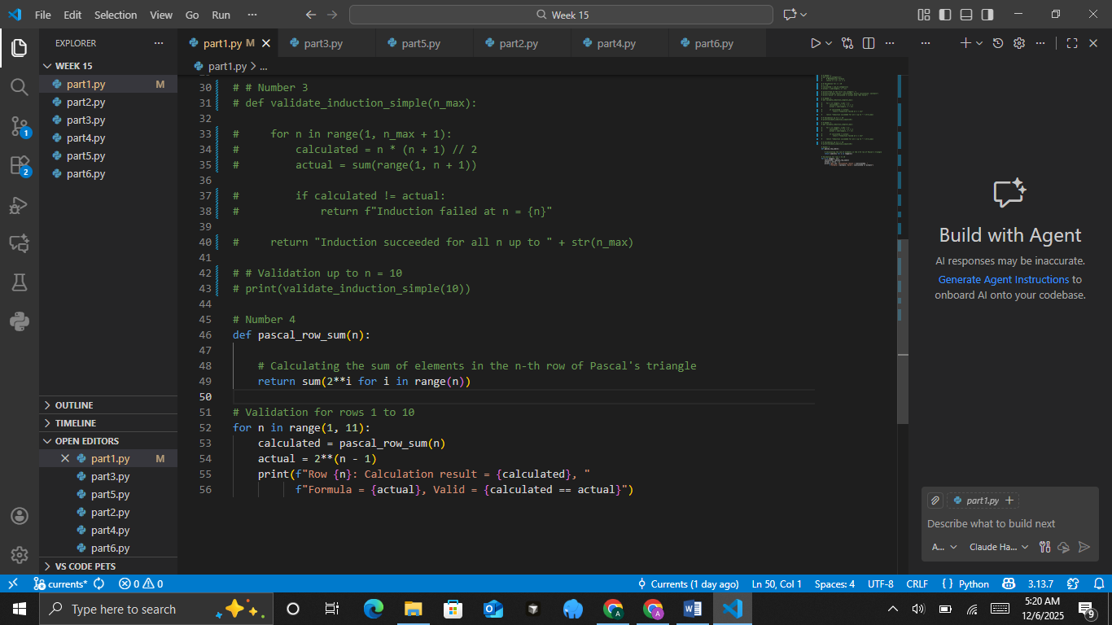
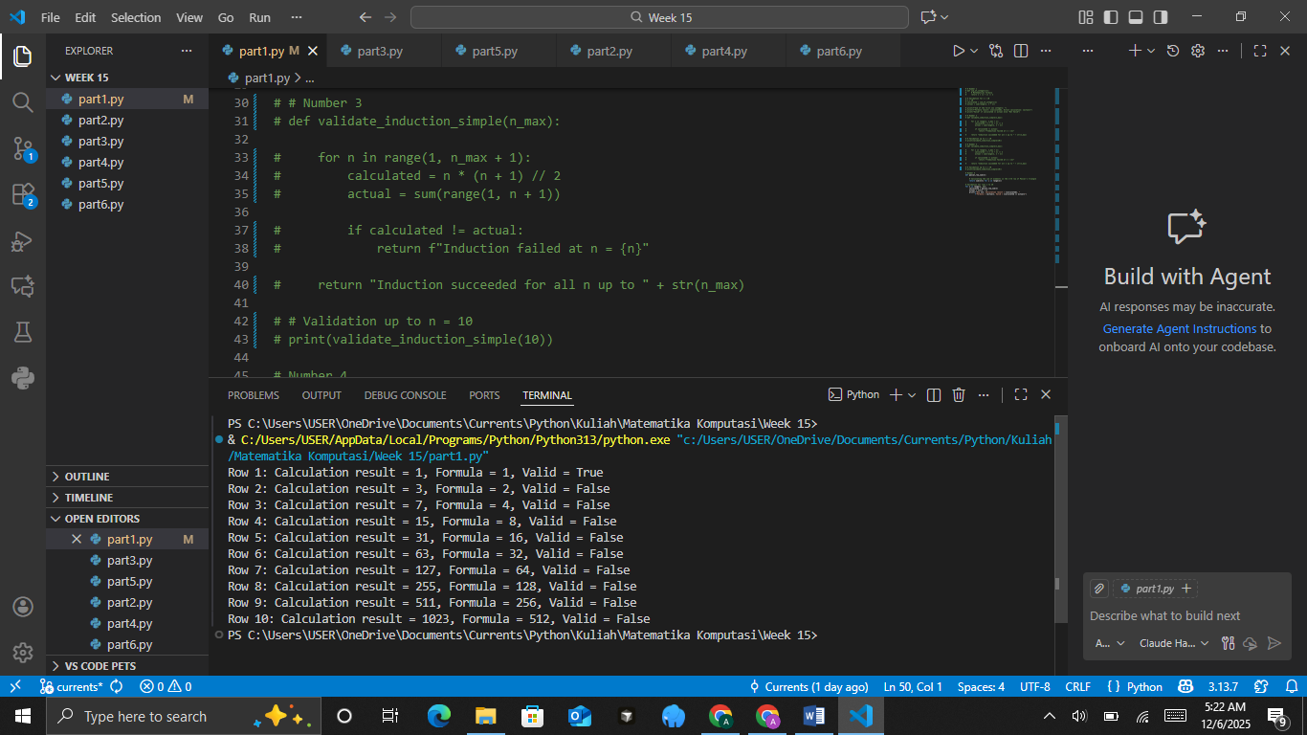
The Analysis
Conclusion:
With this module, students learn to:
1. Understand the basics of mathematical induction.
2. Use Python to validate and simulate mathematical formulas.
3. Apply programming logic in proving mathematical concepts.

PRACTICUM Part 2: Practice Exercises of Statements Regarding Integers., Simple Induction Principle., Extended Induction Principle.
- Statements Regarding Integers
Given the statement:
For every positive integer n, the sum of the first odd numbers satisfies
1+3+5+…+(2n-1) = n^2
Practicum Steps:
- Write a Python function sum_odd(n) to compute the sum of the first n odd numbers.
- Compare the computed result with the value n2.
- Add comments in each part of the code to explain the calculation steps.
- Display test results for several values of n, for example n=3, 6, and 10.
- In the comments, include an explanation of how a mathematical statement like this is used in the context of integers.
The Source Code with output
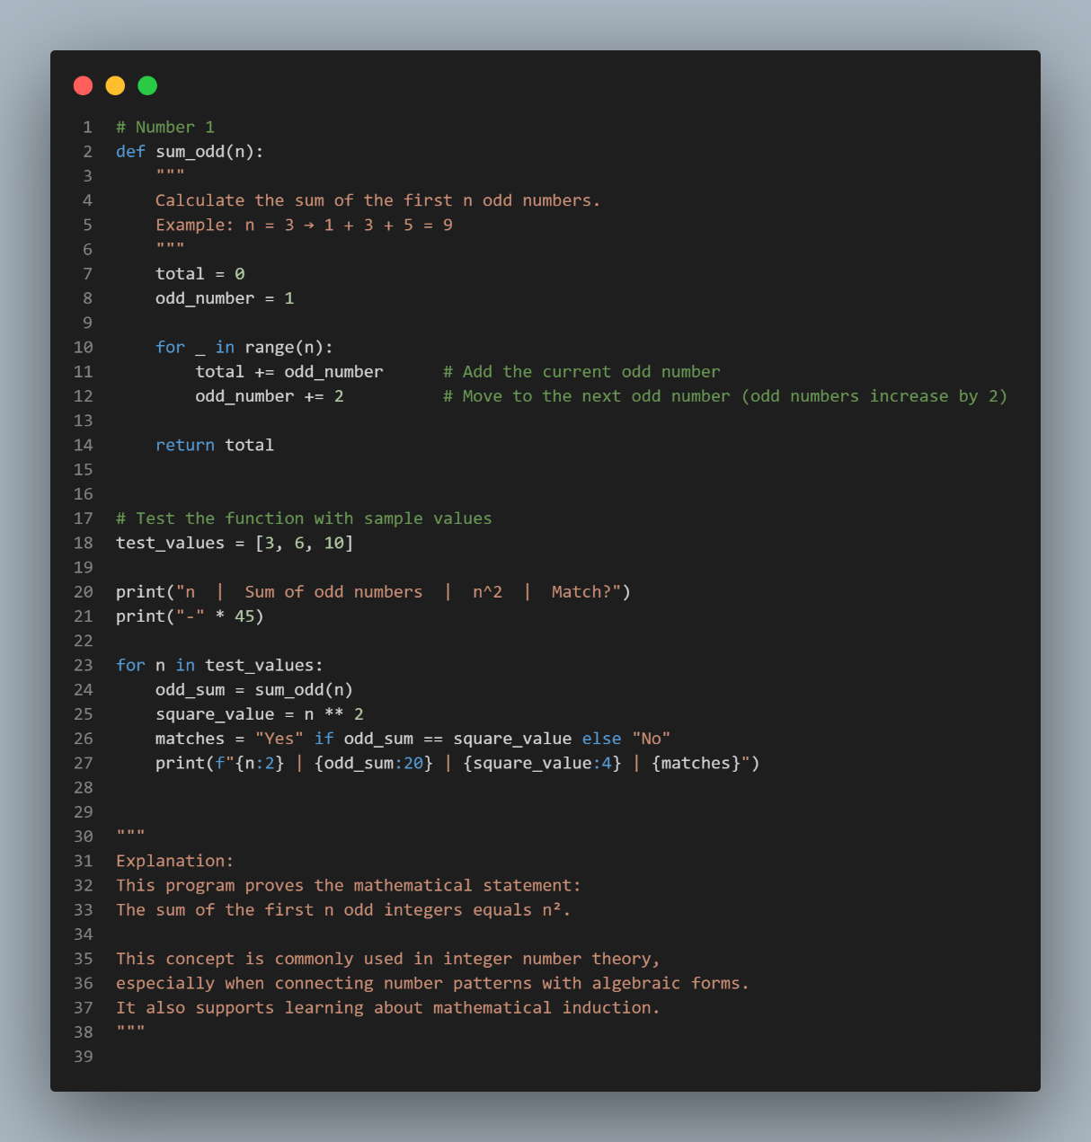
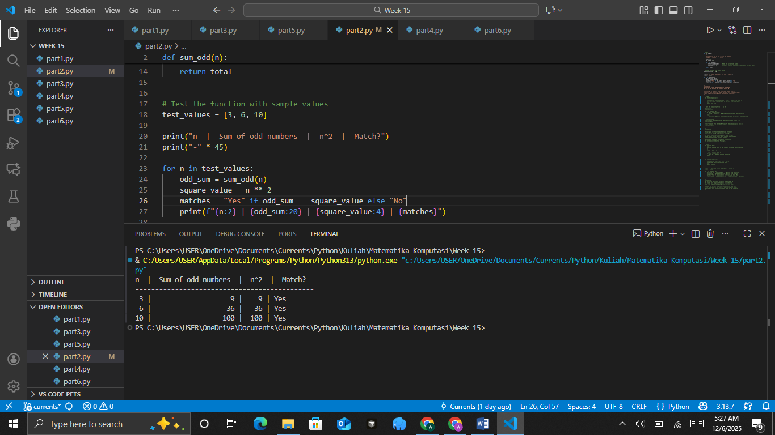
The Analysis

- Simple Induction Principle
Given the statement:
For every positive integer n,
2n ≥ n+1
Practicum Steps:
- Create a Python function check_inequality(n) to test whether 2n ≥ n+1.
- Use a loop to check n from 1 through 15.
- Add comments on each important line of code.
- Display the lists of n values that satisfy the inequality and those that do not (if any).
- In the comments, explain conceptually how the base case and the simple induction step work.
The Source Code with output
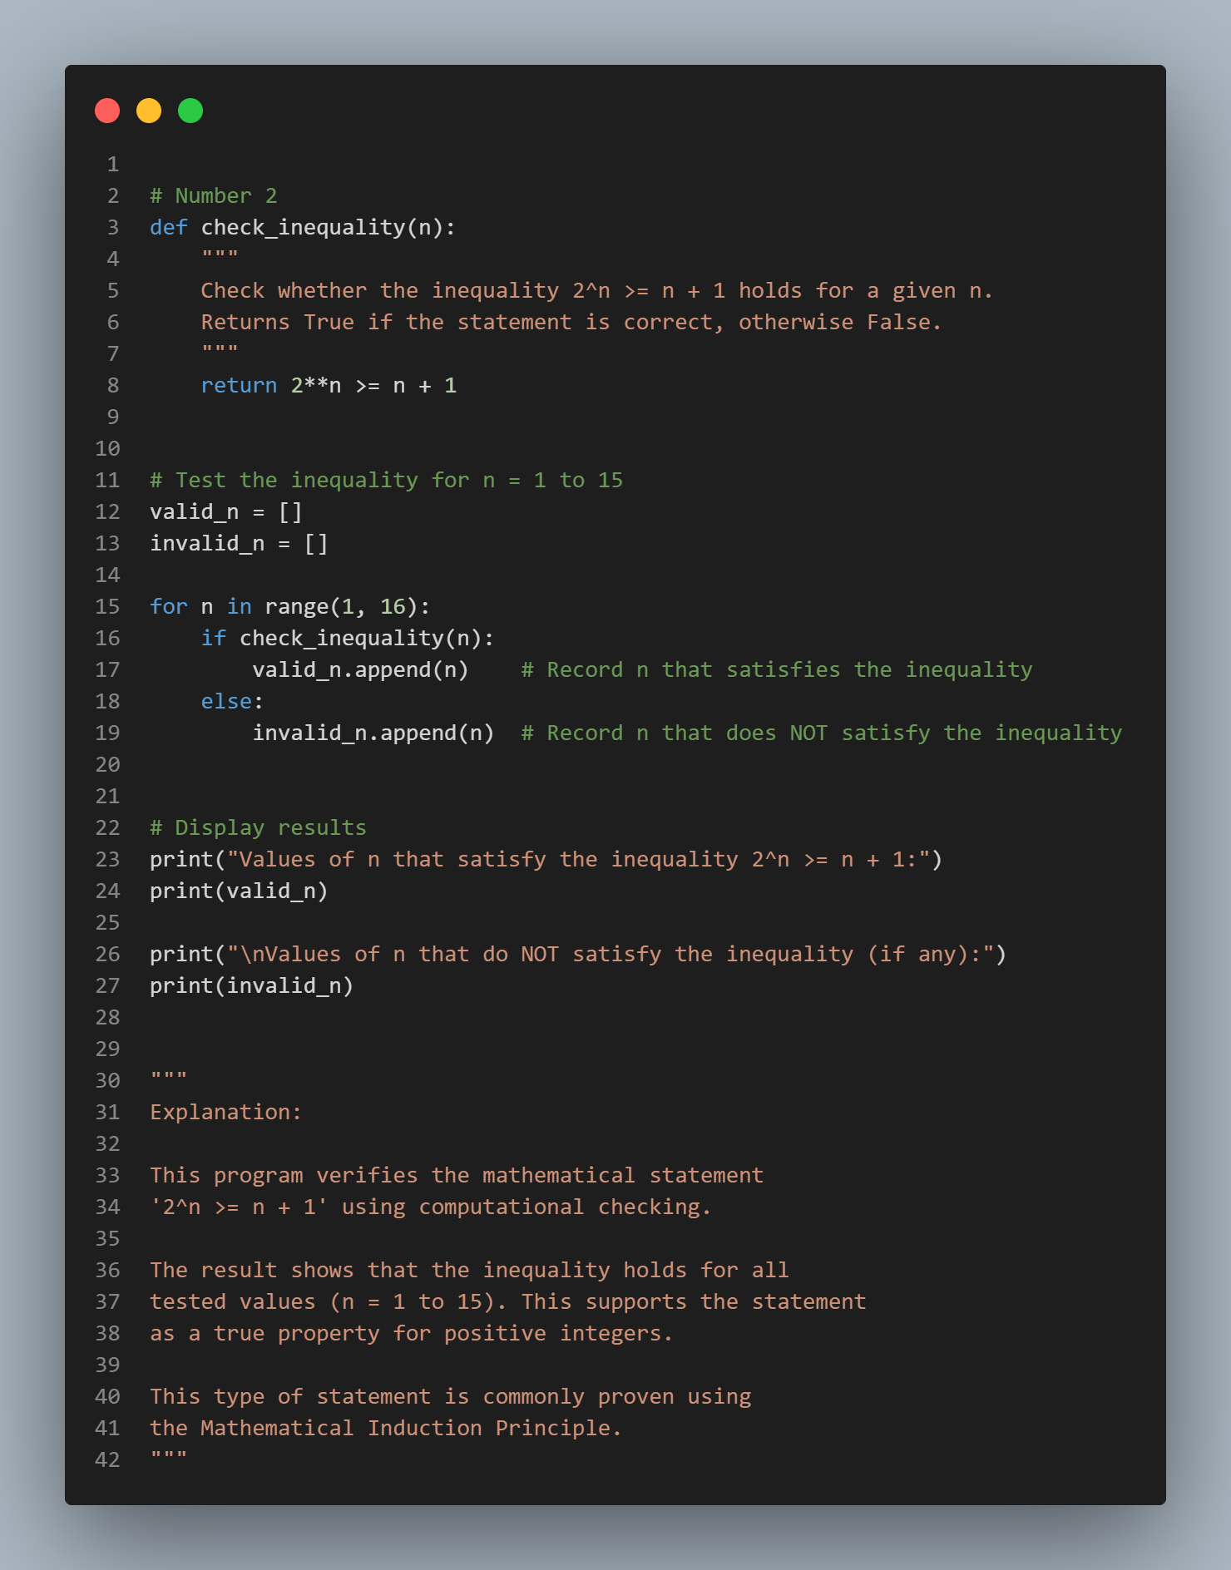
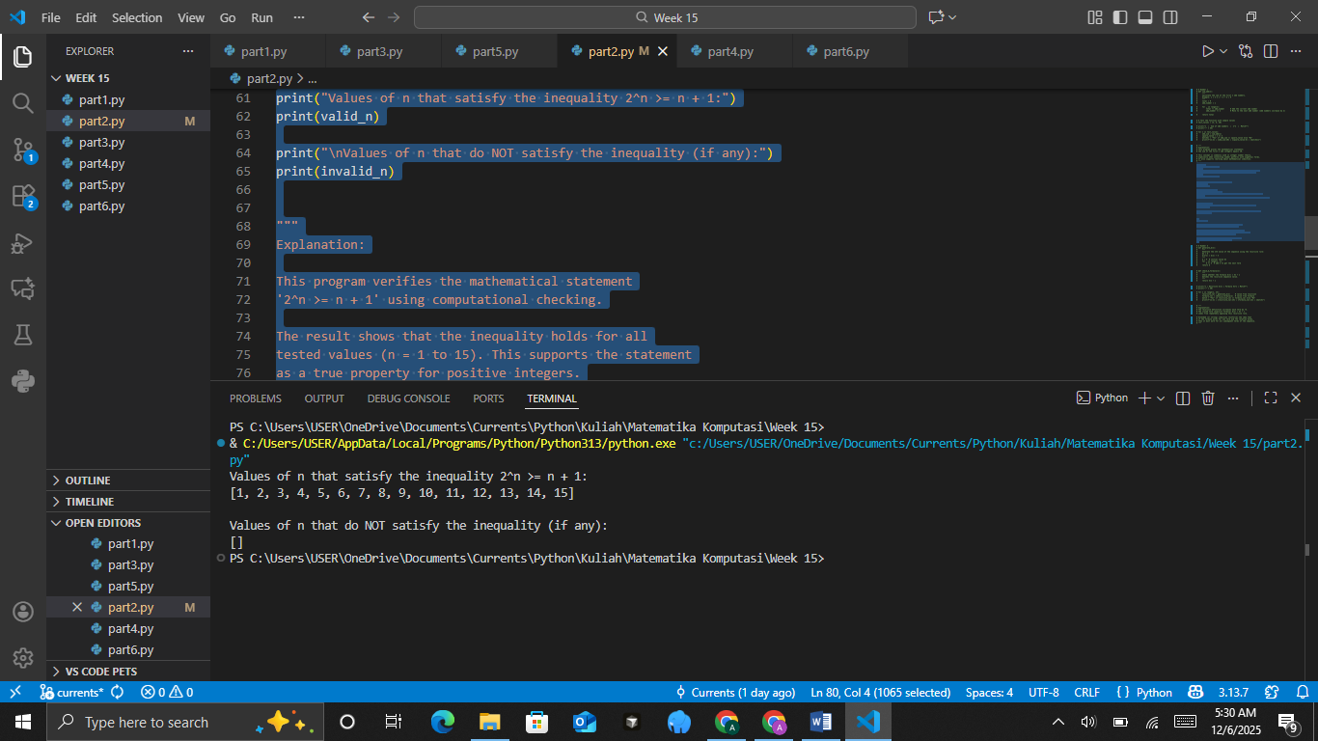
The Analysis

- Extended Induction Principle
Given the recursive sequence:
b1​ = 5,bn+1 ​= bn​+4.
Show that
bn​ = 4n+1.
Practicum Steps:
- Create a Python function generate_b(n) that produces the sequence values according to the recursive definition.
- Create a Python function check_b_formula(n) to verify agreement with the formula 4n+1.
- Add comments explaining the recursion process.
- Test for n from 1 through 12.
- In your comments, explain how strong (complete) induction reinforces the ordinary induction step.
The Source Code with output
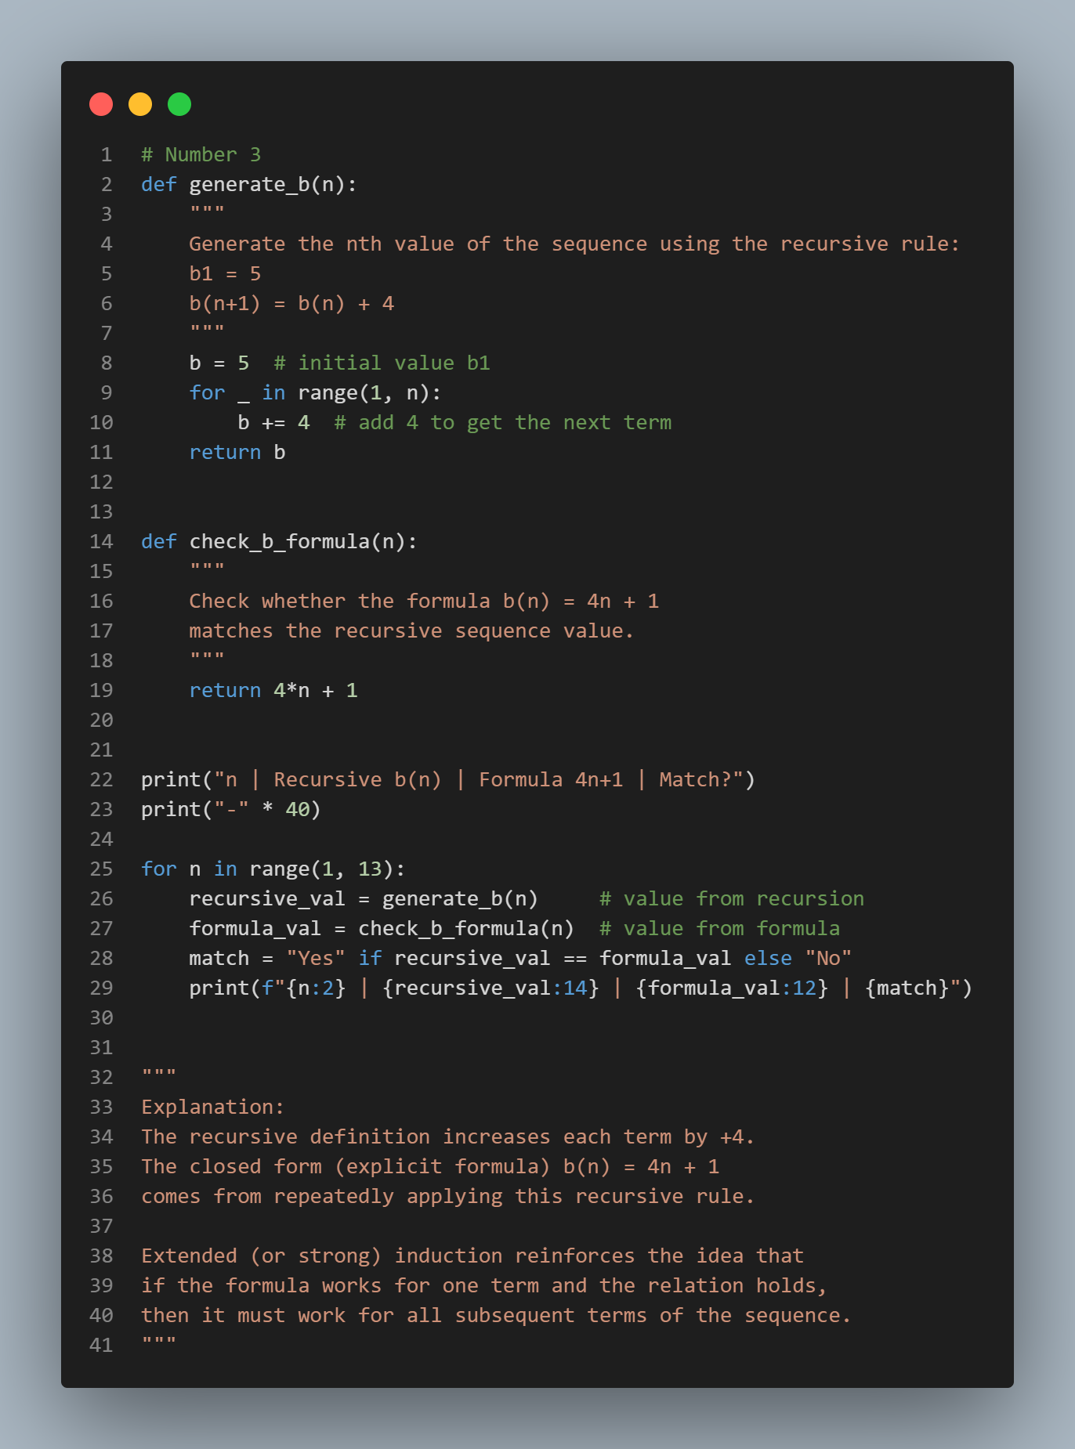
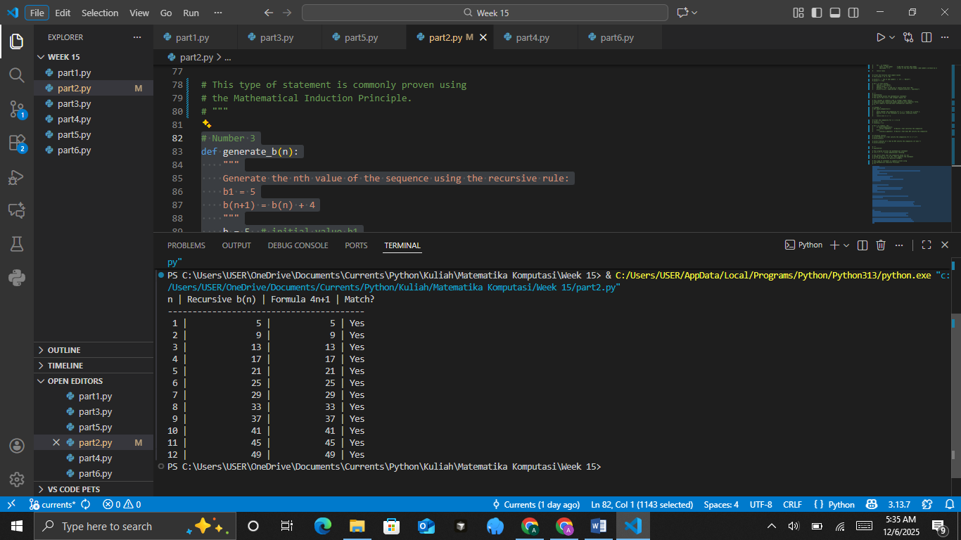
The Analysis

PRACTICUM Part 3: Applications of Strong Induction Principle., General Form of Induction.
- Strong Induction Principle
Strong Induction extends the ordinary (weak) induction principle. To prove that a statement P(n) holds for all n ≥ k, one proceeds as follows:
- Base case
Show that P(k) is true.
- Induction hypothesis
Assume that P(k), P(k+1),…, P(m) are all true for some m≥k.
- Induction step
Using the assumption that P(k), P(k+1),…, P(m) are true, prove that P(m+1) also holds.
The Source Code
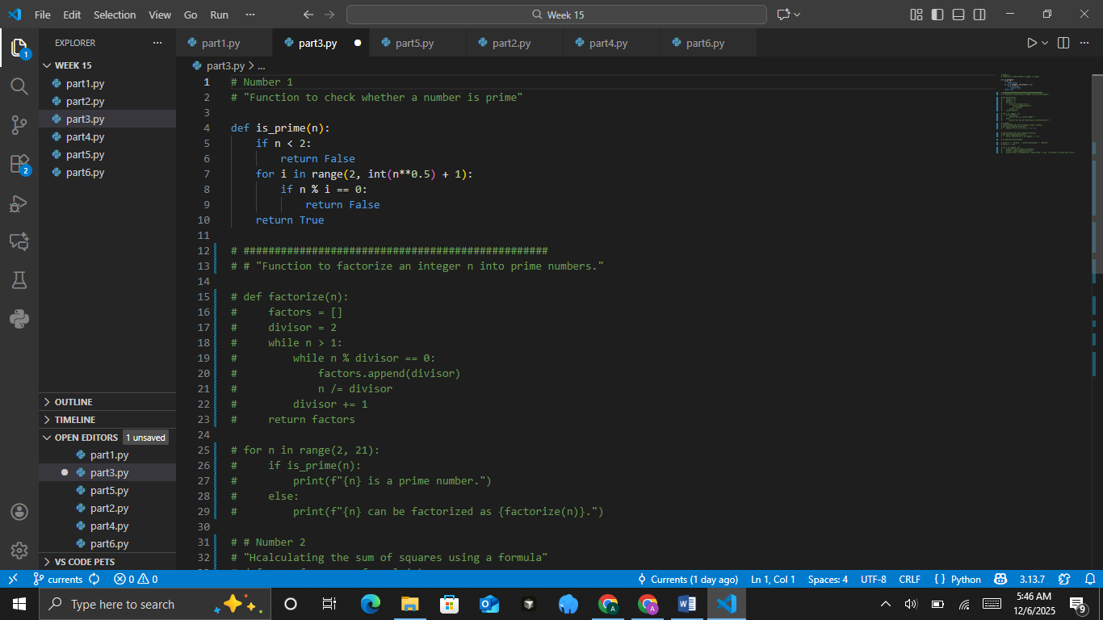
Strong induction can be used to prove statements that require dependence on many earlier cases, not just the single case P(m) to establish P(m+1).
The Source Code with output
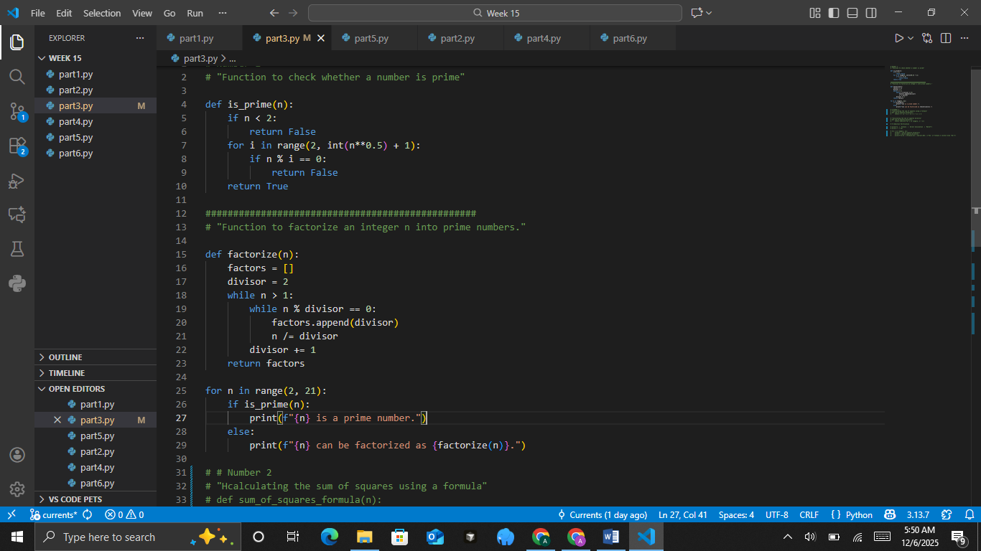
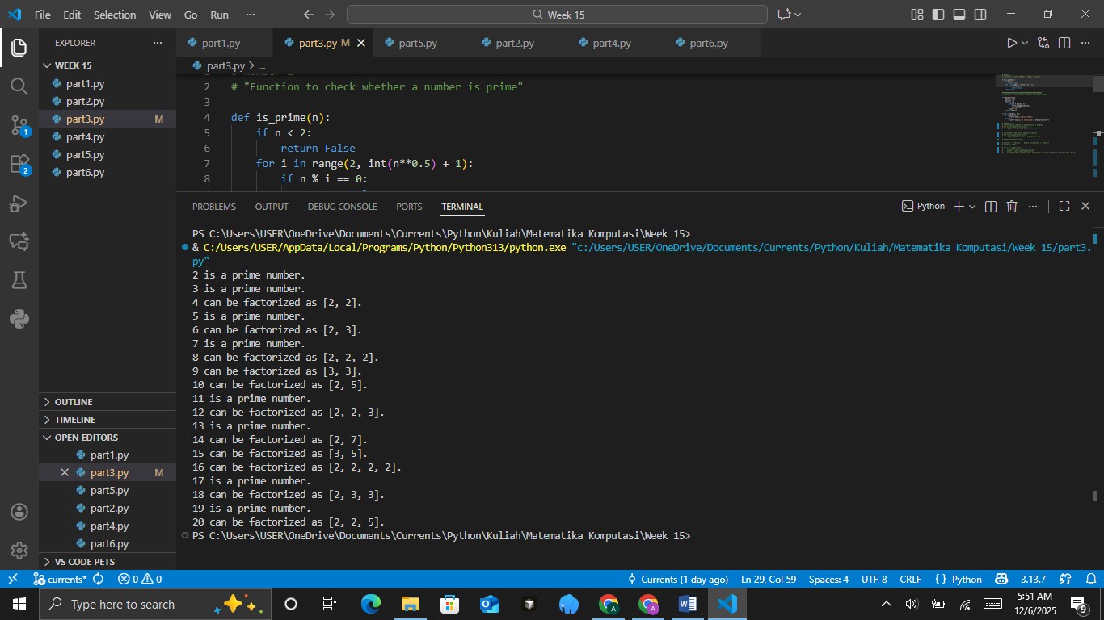
Prime Factorization
• Statement
Every integer n≥2 can be factored as a product of prime numbers.
• Base Case
For n=2, the number itself is prime.
• Induction Hypothesis
Assume the statement holds for all integers k with 2≤k≤m.
• Induction Step
Show the statement holds for m+1.
• If m+1 is prime, then it is already a product of primes (just itself).
• Otherwise, m+1 can be written as a product of two smaller integers. By the induction hypothesis, each of those smaller integers can be factored into primes. Hence m+1 too can be expressed as a product of primes.
The accompanying code checks whether n is prime (the base case). If it is not, it factors n using an iterative algorithm that relies on the fact that smaller numbers have already been factored (the induction step). When run for the integers from 2 through 20, the program verifies that each number can be factored into primes, in accordance with the Strong Induction principle.

- General from of inductions
General Form of Induction does not necessarily begin at a small fixed number like 1 or 2, but can start from an arbitrary base index (k0). As with any induction principle, it requires two parts:
- Base case
Show that P(k0​) is true.
- Induction step
Show that for every m≥k0​, the truth of P(m) implies P(m+1).
Prove that for all n≥1,
1^2+2^2+⋯+n^2=n(n+1)(2n+1)​/6
The Source Code with output
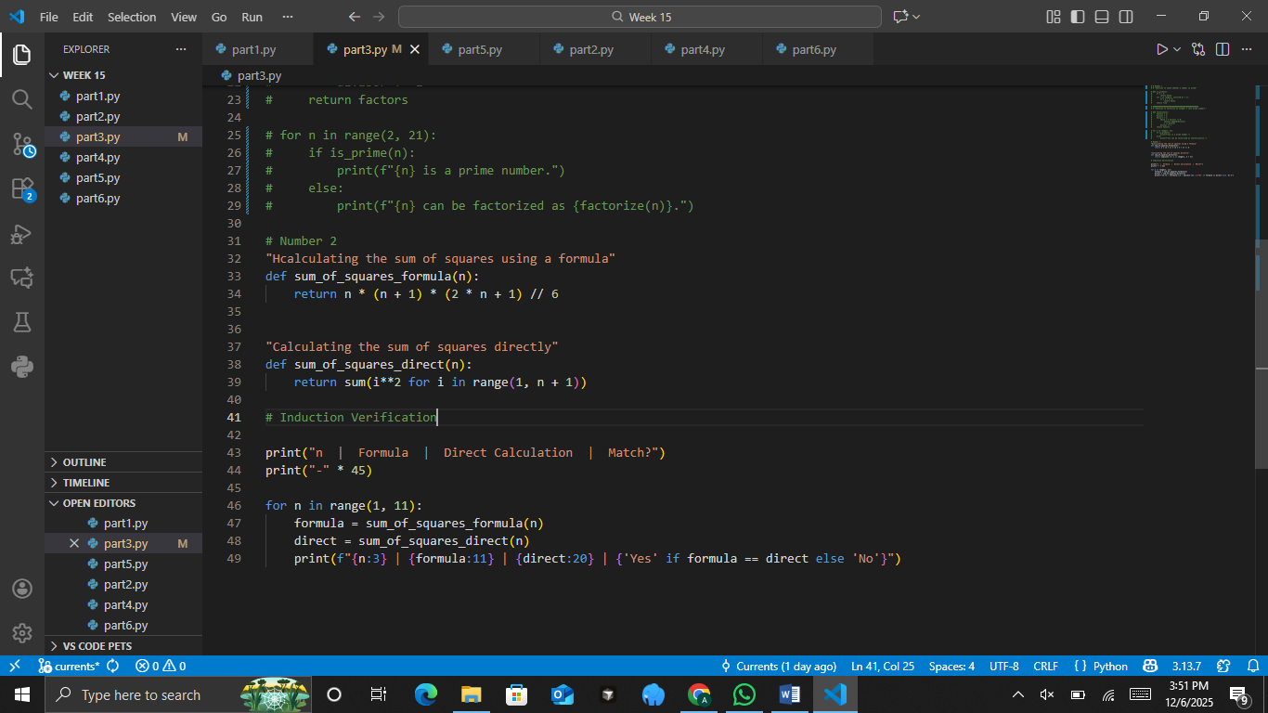
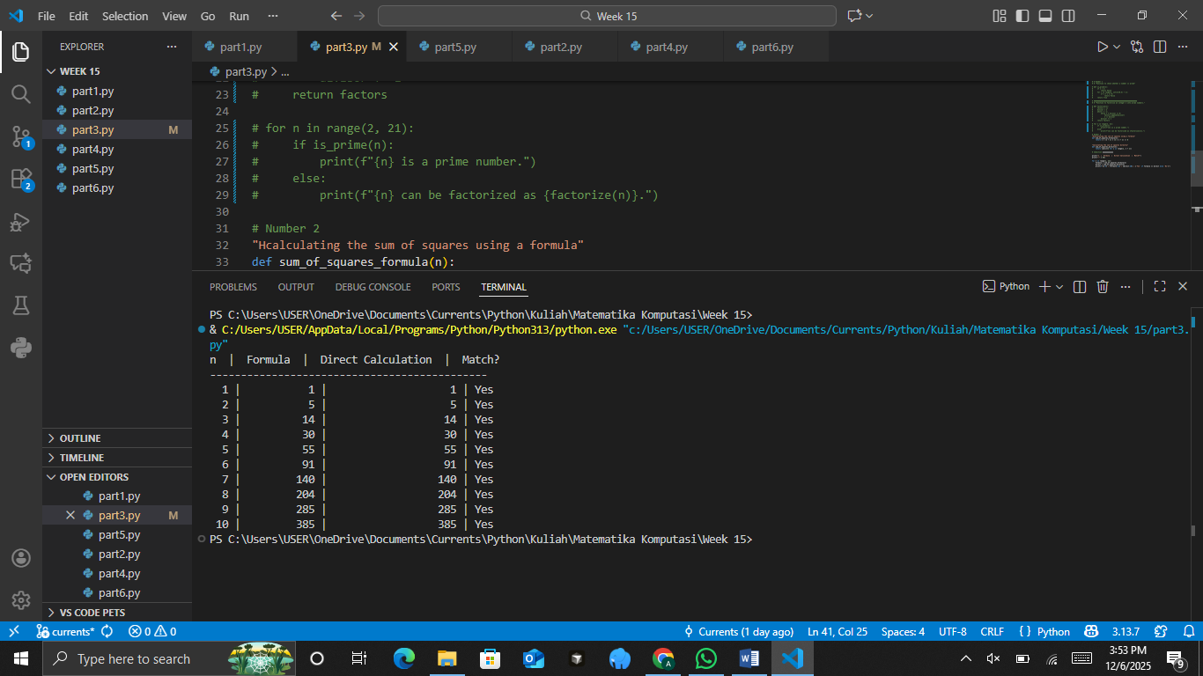
This code compares the direct computation against the closed‐form formula, demonstrating consistency with the principle of induction. The output shows that S(n) matches the formula for n = 1 through n = 10, thereby validating the general‐form induction.

- Theoretical Concepts
Strong Induction Principle
The strong induction principle extends the simple (weak) induction concept by taking into account all previous cases in the inductive step. This makes it possible to prove statements that depend on more than one earlier case.
General Form of Induction
Mathematical induction in its general form introduces the flexibility to begin a proof from an arbitrary base integer (not necessarily n=1) and to employ a more complex induction pattern.
Relevance of the Theory to Computational Mathematics
- Algorithm Development
Induction is the foundation for proving the correctness of algorithms, whether in recursive or iterative form. By understanding these induction principles, students can design algorithms that are both robust and mathematically sound.
- Complexity Analysis
Much of algorithmic complexity analysis relies on mathematical proofs by induction for example, verifying recursive relations or establishing the accuracy of an algorithm’s running time.
- Application in Programming
The concept of induction maps directly to programming techniques in Python, such as iteration, recursion, or dynamic-programming solutions. This demonstrates a direct link between the theory and practical applications.
- Foundation of Mathematical Logic
Strong induction and its general form provide the basis for formal logic systems, which are often employed in the development of formally verified software such as security-critical systems and safety-critical algorithms.

Conclusion:
The Strong Induction Principle and General-Form Induction are fundamental concepts that form the foundation of computational theory. In Computational Mathematics, these concepts are used to prove an algorithm’s correctness and efficiency. Integrating the theory with Python helps students both understand and apply how mathematical abstractions translate into real-world computational technology.

PRACTICUM Part 4: Practice Exercises of Strong Induction Principle., General Form of Induction.
- Strong Induction Principle
Statement:
Every integer n≥2 can be represented as the product of prime numbers.
Practicum steps:
• Create a Python function is_prime(n) to perform a simple primality test.
• Create a function prime_factorization(n) to produce the prime factors of a number.
• Display the results for n=10 to 30.
• Add comments to each step of the code.
• Include a note in the comments explaining how strong induction is used to prove the prime factorization property.
The Source Code with output
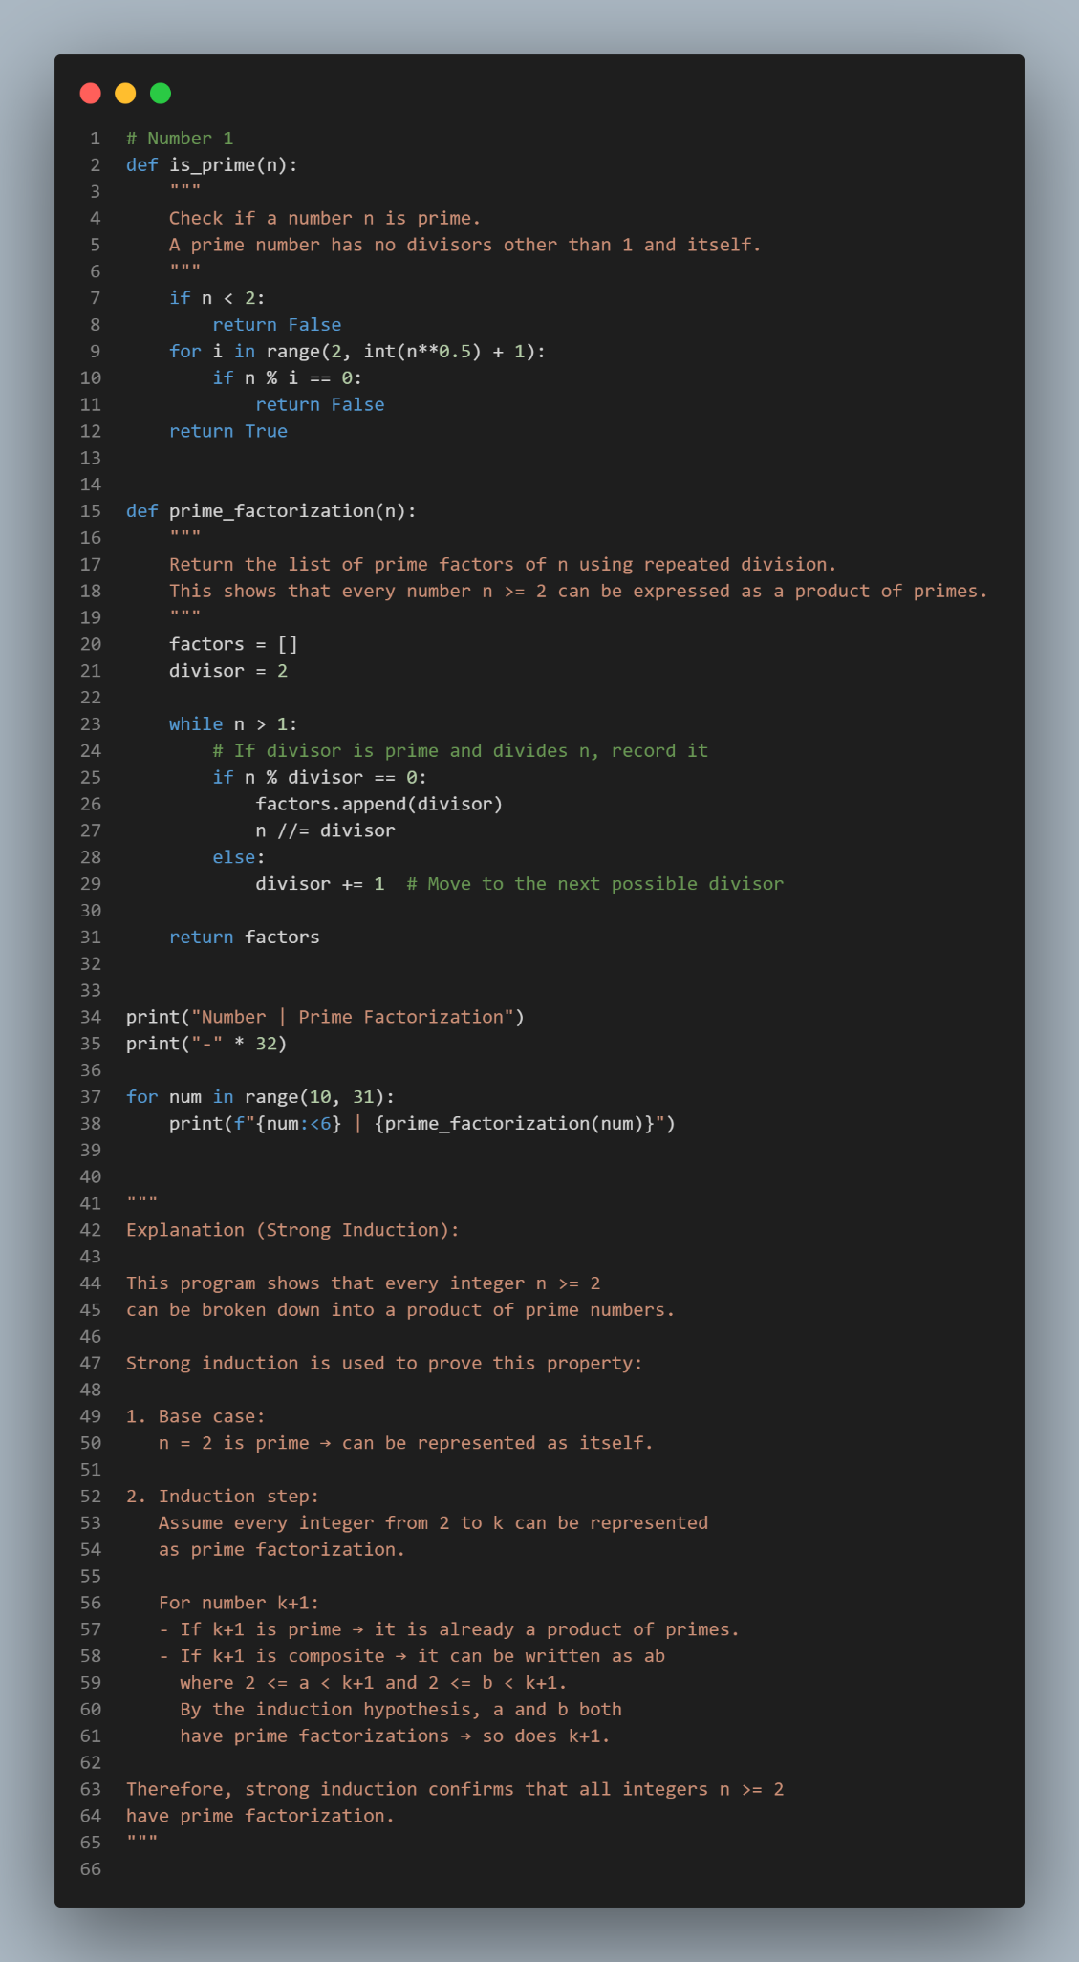
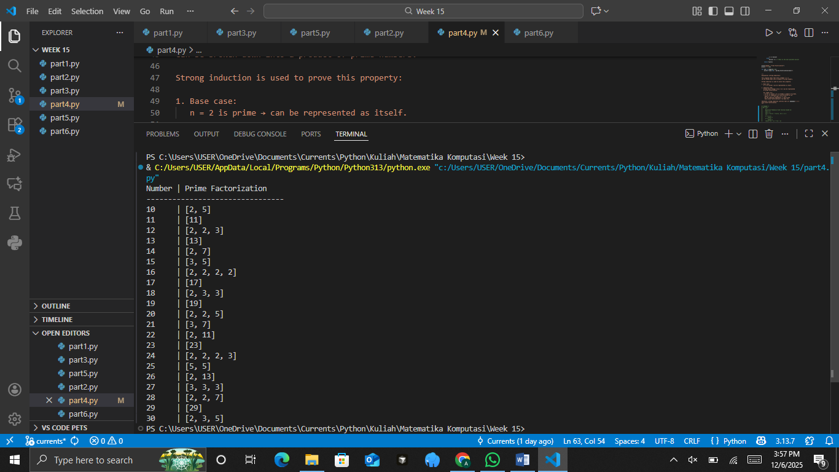
The Analysis

- General form of Induction
Statement:
If a recursive function is defined by
(1) = 1, 𝑓(2) = 2, 𝑓(𝑛) = 𝑓(𝑛 − 1) + 𝑓(𝑛 − 2) for 𝑛 ≥ 3,
then f(n) is the Fibonacci number.
Practicum Steps:
• Create a Python function f(n) according to the definition above.
• Explain through comments how strong induction applies to a function with two “base cases.”
• Create an iterative version fib(n) for comparison.
• Match the values of f(n) and fib(n) for 𝑛 = 1 to 15.
• Add comments to all parts of the code.
The Source Code with output
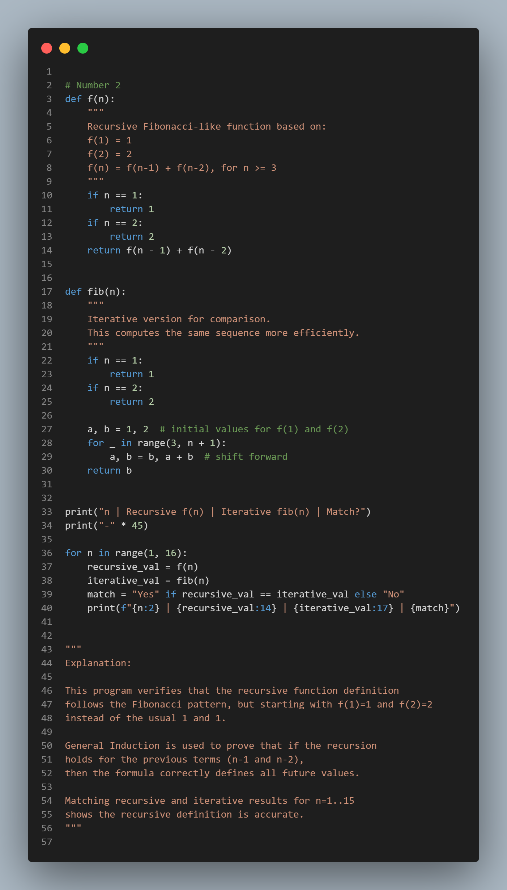
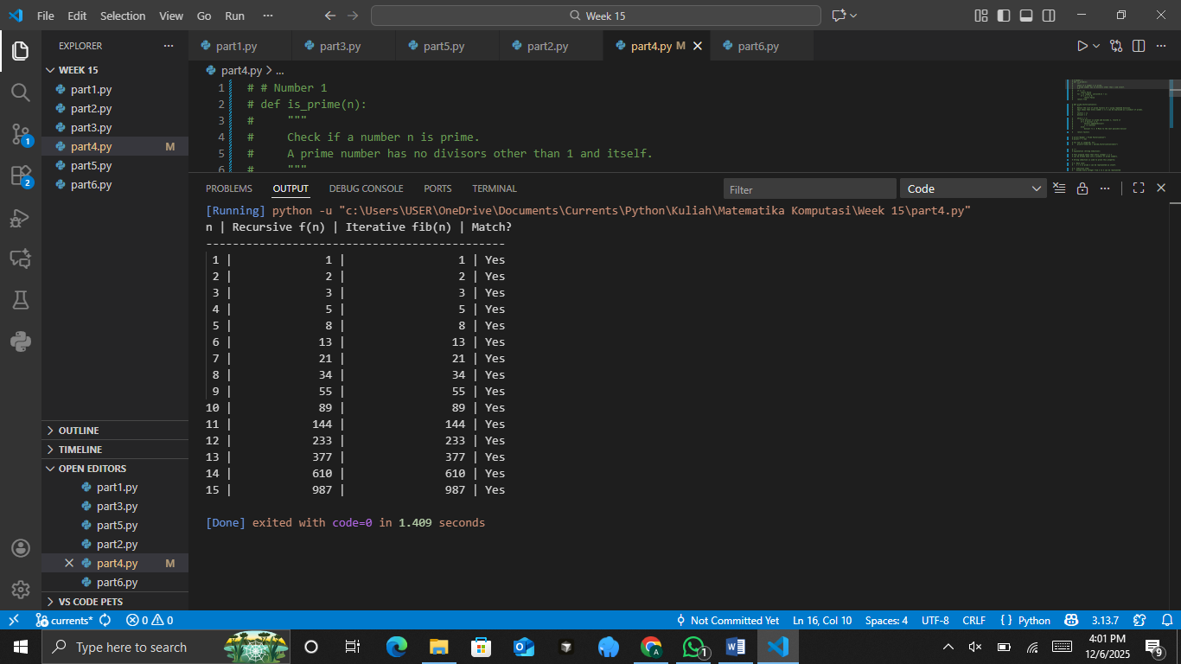
The Analysis

PRACTICUM Part 5: Applications of Algorithms., Notation for Algorithms., Some Examples of Algorithms., Integers.
- Algorithms
Algorithm is a systematic set of steps or instructions for solving a problem. A simple example of an algorithm is the process of calculating the area of a triangle.
The Source Code with output

- Notation for Algorithms
Notation for Algorithms Usually Expressed in Pseudocode, For example:
The Source Code with output

- Some Examples of Algorithms
Example 1: Finding the Largest of Three Numbers
The Source Code with output

Example 2: Summing Numbers from 1 to n
The Source Code with output

- Integers
Integers are the set of positive numbers, negative numbers, and zero. Python provides many built-in functions and operators for working with integers, for example, modulus, floor division, bit-wise operations, and more.
The Source Code with output

Conclusion:
- An algorithm is a logical set of steps for solving a problem.
- Algorithm notation simplifies program development by defining the steps in advance.
- Algorithm examples provide practical understanding for solving various problems.
- Integers can be used in many mathematical operations, such as factorial, prime numbers, or odd/even checks.

PRACTICUM Part 6: Practice Exercises of Algorithms., Notation for Algorithms., Some Examples of Algorithms., Integers.
- Algoritms
Compute the sum of all elements in a list of integers.
Practicum Steps:
- Create a Python function sum_list(L) that calculates the total of the list elements.
- Display the result for the example L = [2, 5, 7, 10].
- Use code comments to explain the purpose of each instruction.
- Compare your function with Python’s built-in sum().
The Source Code with output

The Analysis

- Notations for Algorithms
The Case: Write and Implement Pseudocode for an Algorithm to Find the Maximum Element in a List
Practicum Steps:
- Write pseudocode for an algorithm that finds the maximum value in a list.
- Implement the algorithm in Python as a function called find_max(L).
- Add comments to explain each step of the code.
- Test the function using the list L = [4, 1, 6, 9, 3].
The Source Code with output

The Analysis

- Some Examples of Algorithms
Task: Implement a Linear Search Algorithm
Practicum Steps:
Create a Python function called linear_search(L, x) that searches for an element x in a list L. The function should return the index of x if found, and -1 otherwise. Test the function with L = [10, 20, 30, 40, 50] and x = 30 (present) and x = 45 (absent).
The Source Code with output

The Analysis

- Integers
Implement an algorithm to determine the GCD (Greatest Common Divisor) of two integers using the subtraction method.
Practicum steps:
• Create a Python function gcd_subtraction(a, b) with the logic:
• If a == b → the GCD is found.
• If a > b → set a = a - b.
• If b > a → set b = b - a.
• Add comments explaining each step.
• Test the function with the pairs (48, 18), (56, 42), and (100, 75).
• Briefly compare the results with the division-based Euclidean algorithm.
The Source Code with output

